What is a Computer?

A computer is an electronic device that manipulates information, or "data." It has the ability to store, retrieve, and process data. You can use a computer to type documents, send email, and browse the internet. You can also use it to handle spreadsheets, accounting, database management, presentations, games, and more.

Computers Simplified

For beginning computer users, the computer aisles at an electronics store can be quite a mystery, not to mention overwhelming. However, computers really aren't that mysterious. All types of computers consist of two basic parts:

Hardware is any part of your computer that has a physical structure, such as the computer monitor or keyboard.

Software is any set of instructions that tells the hardware what to do. It is what guides the hardware and tells it how to accomplish each task. Some examples of software are web browsers, games, and word processors such as Microsoft Word.

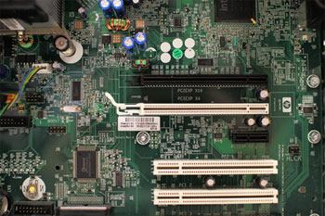

Anything you buy for your computer can be classified as either hardware or software. Once you learn more about these items, computers are actually very straightforward.

The first electronic computer, the Electronic Numerical Integrator and Computer (ENIAC), was developed in 1946. It took up 1,800 square feet and weighed 30 tons.

What are the Different Types of Computers?

When most people hear the word "computer," they think of a personal computer such as a desktop or laptop computer. However, computers come in many shapes and sizes, and they perform many different functions in our daily lives. When you withdraw cash from an ATM, scan groceries at the store, or use a calculator, you're using a type of computer.

Desktop Computers

Many people use desktop computers at work, home, school, or the library. They can be small, medium, or large in style, and usually sit on a desk. Once you add a monitor, mouse, and a keyboard, you have what is typically known as a desktop computer.

Most desktop computers are easy to upgrade and expand, or add new parts. Another benefit of desktop computers is the cost. If you compare a desktop and a laptop with the same features, you will most likely find that the desktop computer is priced lower.

Some desktop computers have a built-in monitor to save space. These are often called all-in-one desktop computers.

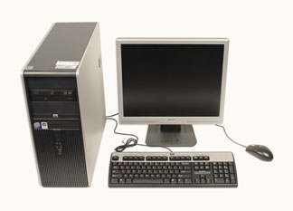

Laptop Computers

The second type of computer that you may be familiar with is a laptop computer, or a laptop. Laptops are battery- or AC-powered personal computers that are more portable than desktop computers, allowing you to use them almost anywhere.

Since a laptop is smaller than a desktop, it's more difficult to access the internal components. That means you may not be able to upgrade them as much as a desktop. However, it's usually possible to add more RAM or a bigger hard drive.

A laptop computer is sometimes called a notebook computer because of its size.

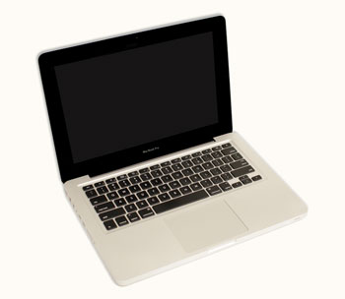

Servers

A server is a computer that "serves up" information to other computers on a network. Many businesses have file servers that employees can use to store and share files. A server can look like a regular desktop computer, or it can be much larger.

Servers also play an important role in making the internet work: They are where webpages are stored. When you use your browser to click a link, a web server delivers the page you requested.

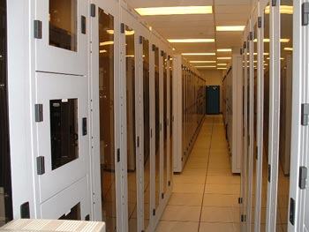

Other Types of Computers

Today, there lots of everyday devices that are basically specialized computers, even though we don't always think of them as computers. Here are a few common examples:

Tablet Computers: These use a touch-sensitive screen for typing and navigation. Since they don't require a keyboard or mouse, tablet computers are even more portable than laptops. The iPad is an example of a tablet computer.

Mobile Phones: Many mobile phones can do a lot of things a computer can do, such as browsing the internet or playing games. These phones are often called smartphones.

Game Consoles: A game console is a specialized kind of computer that is used for playing video games. Although they are not as fully featured as a desktop computer, many newer consoles, such as the Nintendo Wii, allow you to do non-gaming tasks like browsing the internet.

TVs: Many TVs now include applications (or apps) that let you access various types of online content. For example, you can view your Facebook news feed or watch streaming movies on Netflix.

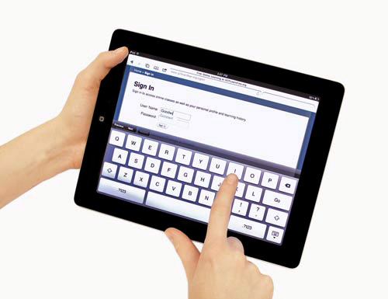

PCs and Macs

Personal computers come in two main "styles:" PC and Mac. Both styles are fully functional, but they do have a different look and feel, and many people prefer one or the other.

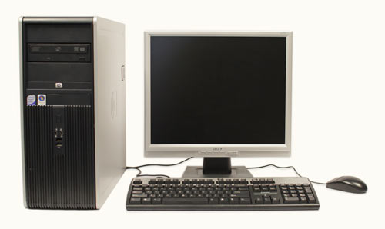

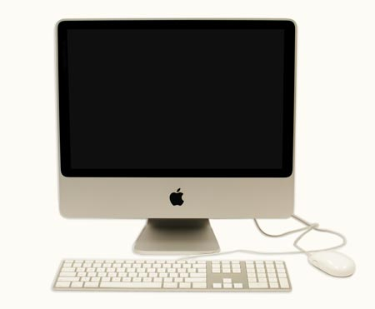

PC: This type of computer began with the original IBM PC that was introduced in 1981. Other companies began to create similar computers, which were called IBM PC Compatible (often shortened to PC). Today, this is the most common type of personal computer, and it typically includes the Microsoft Windows operating system.

Mac: The Macintosh computer was introduced in 1984, and it was the first widely sold personal computer with a Graphical User Interface, or GUI (pronounced gooey). All Macs are made by one company, Apple Inc., and they almost always use the Mac OS X operating system.

Although PC can refer to an IBM PC Compatible, the term can also be used to refer to any personal computer, including Macs.

What is an Operating System?

An operating system is the most important software that runs on a computer. It manages the computer's memory, processes, and all of its software and hardware. It also allows you to communicate with the computer without knowing how to speak the computer's "language." Without an operating system, a computer is useless.

The Operating System's Job

You've probably heard the phrase boot your computer, but do you know what that means? Booting is the process that occurs when you press the power button to turn your computer on. During this process (which may take a minute or two), the computer does several things:

•It runs tests to make sure everything is working correctly.

•It checks for new hardware.

•It then starts up the operating system.

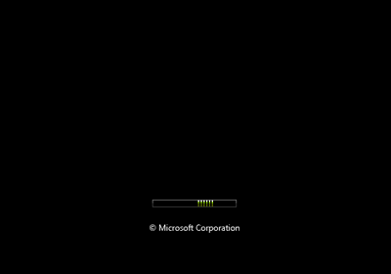

Once the operating system has started up, it manages all of the software and hardware on the computer. Most of the time, there are many different programs running at the same time, and they all need to access your computer's Central Processing Unit (CPU), memory, and storage. The operating system coordinates all of this to make sure that each program gets what it needs. Without the operating system, the software wouldn't even be able to talk to the hardware, and the computer would be useless.

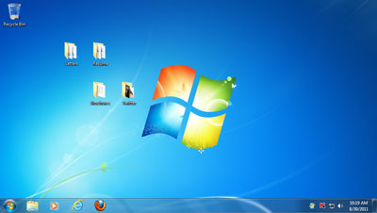

Types of Operating Systems

Operating systems usually come preloaded on any computer that you buy. Most people use the operating system that comes with their computer, but it is possible to upgrade or even change operating systems.

The three most common operating systems for personal computers are Microsoft Windows, Apple Mac OS X, and Linux.

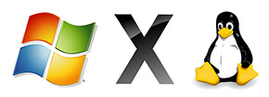

Modern operating systems use a Graphical User Interface, or GUI (pronounced "gooey"). A GUI lets you use your mouse to click on icons, buttons, and menus, and everything is clearly displayed on the screen using a combination of graphics and text.

Each operating system's GUI has a different look and feel, so if you switch to a different operating system it may seem unfamiliar at first. However, modern operating systems are designed to be easy to use, and most of the basic principles are the same.

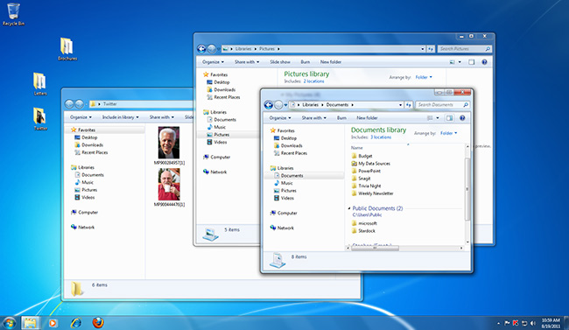

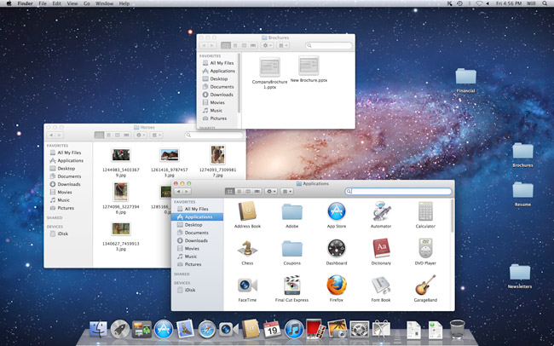

Before GUIs, computers had a **command-line interface**, which meant the user had to type every single command to the computer, and the computer would only display text.

Microsoft Windows

Microsoft created the Windows operating system in the mid-1980s. Over the years, there have been many different versions of Windows, but the most recent ones are Windows 8 (released in 2012), Windows 7 (2009), and Windows Vista (2007). Windows comes preloaded on most new PCs, which helps to make it the most popular operating system in the world.

If you're buying a new computer or upgrading to a newer version of Windows, you can choose from several different editions of Windows, such as Home Premium, Professional, and Ultimate. You may need to do some research to decide which edition is right for you.



Apple Mac OS X

Mac OS is a line of operating systems created by Apple Inc. It comes preloaded on all new Macintosh computers, or Macs. All of the recent versions are known as Mac OS X (pronounced Mac O-S Ten), and the specific versions include Mavericks (released in 2013), Mountain Lion (2012), Lion (2011), and Snow Leopard (2009). Apple also offers a version called Mac OS X Server, which is designed to be run on servers.

According to StatCounter Global Stats, Mac OS X users account for 7.5% of the operating systems market as of January 2013—much lower than the percentage of Windows users (more than 90%). One reason for this is that Apple computers tend to be more expensive. However, many people prefer the look and feel of Mac OS X.



Linux

Linux (pronounce LINN-ux) is a family of open-source operating systems, which means that they can be modified and distributed by anyone around the world. This is very different from proprietary software like Windows, which can only be modified by the company that owns it (Microsoft). The advantages of Linux are that it is free, and there are many different distributions (or versions) that you can choose from. Each distribution has a different look and feel, and the most popular ones include Ubuntu, Mint, and Fedora.

Linux is named after Linus Torvalds, who created the Linux kernel in 1991. The kernel is the computer code that is the central part of an operating system.

According to StatCounter Global Stats, Linux users account for less than 1% of the operating systems market as of January 2013. However, most servers run Linux because it's relatively easy to customize.

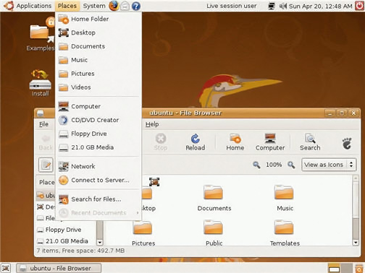

Operating Systems for Mobile Devices

The operating systems that we've been talking about were designed to run on desktop or laptop computers. Mobile devices such as phones, tablet computers, and mp3 players are very different from desktop and laptop computers, so they run operating systems that are designed specifically for mobile devices. Examples of mobile operating systems include Apple iOS, Windows Phone, and Google Android.

Operating systems for mobile devices generally aren't as fully featured as those made for desktop or laptop computers, and they aren't able to run all of the same software. However, you can still do a lot of things with them, such as watching movies, browsing the internet, managing your calendar, playing games, and more.

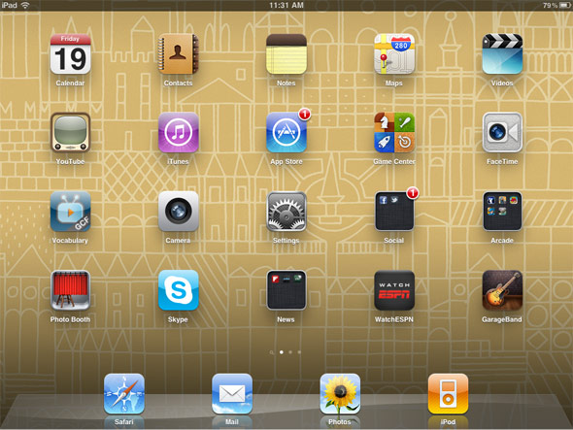

What is an application?

You may have heard people talking about using an application or an app. But what exactly does that mean? An app is a type of software that allows you to perform specific tasks. Applications for desktop or laptop computers are sometimes called desktop applications, and those for mobile devices are called mobile apps. When you open an application, it runs inside the operating system until you close it. Much of the time, you will have more than one application open at the same time, and this is known as multitasking.

App is a very common term for an application, especially for simple applications that can be downloaded cheaply or even for free. Many apps are also available for mobile devices and even some TVs.

Types of Desktop Applications

There are countless desktop applications out there, and they fall into many different categories. Some are more full-featured (like Microsoft Word), while others may only do one or two things (like gadgets). Below are just a few types of applications that you might use:

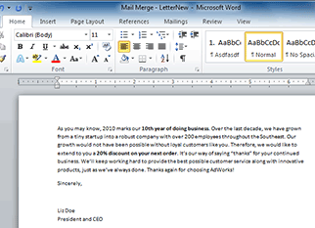

Word Processors: A word processor allows you to write a letter, design a flyer, and create many other kinds of documents. The most well-known word processor is Microsoft Word.

Personal Finance: Personal finance software, such as Quicken, allows you to keep track of your income and expenses, create a budget, and more. Most personal finance programs can automatically download information from your bank, so you don't have to manually type in all of your transactions.

Web Browsers: A web browser is the tool that you use to access the World Wide Web. Most computers come with a web browser pre-installed, but you can also download a different one if you prefer. Examples of browsers include Internet Explorer, Firefox, Google Chrome, and Safari.

Games: There are many different games that you can play on your computer. They range from card games such as Solitaire to action games like Halo 2. Many action games require a lot of computing power, so they may not work unless you have a newer computer.

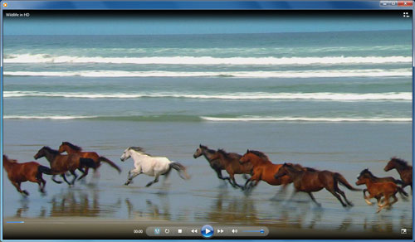

Media Players: If you want to listen to mp3s or watch movies that you've downloaded, you'll need to use a media player. Windows Media Player and iTunes are popular media players.

Gadgets: Sometimes called widgets, these are simple applications that you can place on your desktop (or on the Dashboard if you're using a Mac). There are many different types of gadgets, and they include calendars, calculators, maps, news headlines, and more.

Installing Desktop Applications

In order to work, an application usually has to be installed on your computer. Typically, installation is as simple as inserting the installation disc and following the instructions on the screen. For software that is downloaded from the internet, you can usually double-click it after it is finished downloading and then follow the instructions on the screen. Many applications include a readme file (for example, readme.txt), which includes installation instructions and other information.

Use caution when downloading software, as it can contain viruses or other malware. If you have an antivirus program, you should scan the downloaded software before installing it. For more information, check out Protecting Your Computer from Internet Threats in our Internet Safety tutorial.

Opening Files with Applications

Many applications are designed to open one or more types of files (or file formats). For example, Microsoft Word can create and edit Word documents. If you don't have the right kind of application, you won't be able to open a file. For example, if you are taking our Access 2010 tutorial, you will need to have Microsoft Access in order to open the sample database.

There are two main ways to open a file:

Find the file on your computer, and double-click it. This will open the file using the default program.

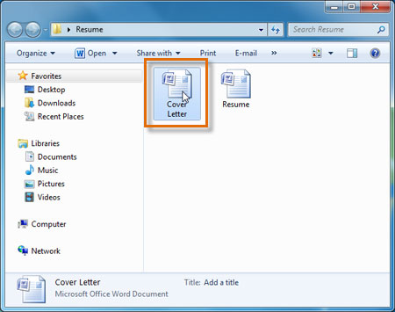

Open the application, then use the application to open the file. Once the application is open, you can go to the File menu at the top of the screen and select Open. This is useful because some files can be opened by several different applications, and this method allows you to choose which application to use.

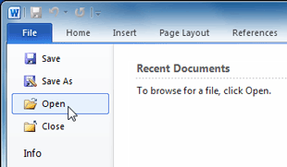

If you're not sure what a file's format is, you can look at the extension at the end of the file name (for example .docx, .txt, or .jpg). On some computers, the extension may be hidden, and you may need to look at the icon to determine the file format.

Mobile Apps

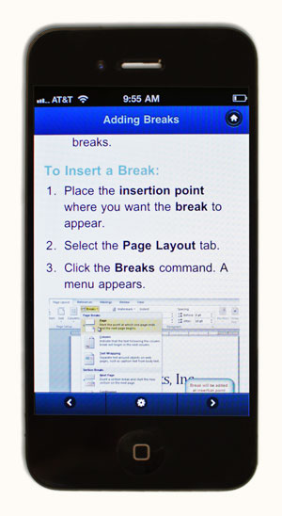

Desktop and laptop computers aren't the only devices that can run apps. You can also download apps for mobile devices like smartphones and tablet computers, which opens up a lot of new possibilities. Here are a few examples of mobile apps:

RedLaser: You can use RedLaser to compare prices while shopping. You simply scan an item's barcode using your phone's built-in camera, and the app searches the Web for the best price.

Word Lens: Word Lens is a language translator app. Like RedLaser, it uses your phone's camera to take a picture of a sign, menu, or other text that you want to translate, and then it displays the translation for you.

Foursquare: If you're going out to a restaurant, bar, or mall, you can "check in" with Foursquare to find nearby friends and also let your friends know where you are. Foursquare can also show you a list of nearby businesses (using your phone's built-in GPS), which can help you discover places that you've never been to before.

Compared to traditional applications, mobile apps are relatively cheap. Many of them cost as little as 99 cents, and others are free. If your mobile device has an internet connection, you can download apps directly onto the mobile device. Otherwise, you can download them to your computer and then transfer them over.

Some of the tutorials on GCFLearnFree.org are available as mobile apps. You can go to our Mobile Apps page to download them for free.

Introduction

The basic parts of a desktop computer are the computer case, monitor, keyboard, mouse, and power cord. Each part plays an important role whenever you use a computer.

Computer Case

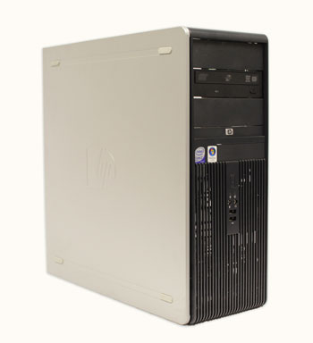

The computer case is the metal and plastic box that contains the main components of the computer. It houses the motherboard, central processing unit (CPU), the power supply, and more.

Computer cases come in different shapes and sizes. A desktop case lies flat on a desk, and the monitor usually sits on top of it. A tower case is tall and sits next to the monitor or on the floor. The front of the case usually has an on/off switch and one or more optical drives.

Most of the personal computers you can purchase today include tower cases rather than desktop cases; however, some computers are being made with all of the internal components built into the monitor, which completely eliminates the tower.



Monitor

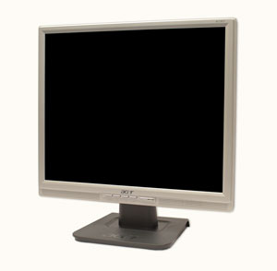

The monitor works with a video card, located inside the computer case, to display images and text on the screen. Newer monitors usually have LCD (liquid crystal display) or LED (light-emitting diode) displays. These can be made very thin, and they are often called flat panel displays. Older monitors use CRT (cathode ray tube) displays. CRT monitors are much bigger and heavier, and they take up more desk space.

Most monitors have control buttons that allow you to change your monitor's display settings, and some monitors also have built-in speakers.

LED displays are actually LCD displays that are backlit with light-emitting diodes. This allows for greater contrast than a traditional LCD display.

Power Cord

The power cord is the link between the power outlet and the power supply unit in the computer casing. If the power cord is not plugged in, the computer will not power on. To protect your computer from voltage spikes, you can plug the power cord into a surge protector. You can also use an Uninterruptable Power Supply (UPS), which acts as a surge protector and also provides temporary power if there is a blackout.

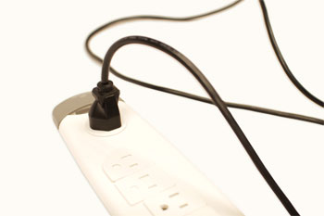

Keyboard

The keyboard is one of the primary ways we communicate with the computer and enter data. There are many different types of computer keyboards, such as wired, wireless, ergonomic, and multimedia. Although there may be differences in the location of some keys or features, keyboards are very similar and allow you to accomplish basically the same tasks.

Mouse

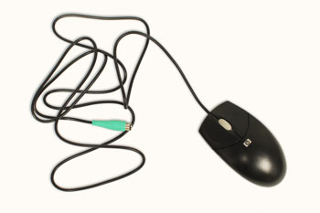

The mouse is a peripheral that is known as a pointing device. It lets you point to objects on the screen, click on them, and move them.

There are two main types of mice: optical and mechanical. The optical mouse uses an electronic eye to detect movement and is easier to clean. The mechanical mouse uses a rolling ball to detect movement. Generally, a mechanical mouse is cheaper, although it may require regular cleaning to keep it working properly.

Traditionally, a mouse connects to the computer using a USB or PS/2 connection. However, you can also buy a wireless mouse, which can reduce clutter on your desktop.

Mouse Alternatives

There are other devices that can do the same thing a mouse can do, but with a different look and feel. Many people find them to be easier to use, and they also require less desk space than a mouse. The most common mouse alternatives include:

A touchpad on a laptop

Trackball: A trackball has a ball on top that can rotate freely. Instead of moving the device like a mouse, you can simply roll the ball with your fingers to move the pointer. Some mobile devices have miniature trackballs that can be controlled with your thumb.

Touchpad: A touchpad (also called a trackpad) is a touch-sensitive pad that lets you control the pointer by making a "drawing" motion with your finger. Touchpads are very common on laptop computers.

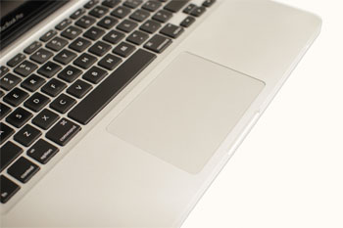

Inside a Desktop Computer

Have you ever looked inside a computer case before, or seen pictures of the inside of one? The small parts may look complicated, but the inside of a computer case really isn't all that mysterious. This lesson will help you master some of the basic terminology and understand a little about what goes on inside the computer casing.

Watch the video to learn about what's inside a desktop computer.

A Look Inside a Desktop Computer

Let's explore the inside of a computer tower.

CPU/Processor

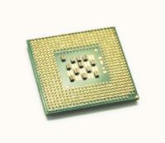A CPU

The Central Processing Unit (CPU), also called a processor, is located inside the computer case on the motherboard. It is sometimes called the brain of the computer, and its job is to carry out commands. Whenever you press a key, click the mouse, or start an application, you're sending instructions to the CPU.

The CPU is generally a 2-inch ceramic square with a silicon chip located inside. The chip is usually about the size of a thumbnail. The CPU fits into the motherboard's CPU socket, which is covered by the heat sink, an object that absorbs heat from the CPU.

A processor's speed is measured in megahertz (MHz), or millions of instructions per second, and gigahertz (GHz), or billions of instructions per second. A faster processor can execute instructions more quickly. However, the actual speed of the computer depends on the speed of many different components—not just the processor.

There are many processor manufacturers for personal computers, but the most well-known ones are Intel and AMD.

Motherboard



The motherboard is the computer's main circuit board. It's a thin plate that holds the CPU, memory, connectors for the hard drive and optical drives, expansion cards to control the video and audio, as well as connections to your computer's ports (such as the USB ports). The motherboard connects directly or indirectly to every part of the computer.

Power Supply Unit

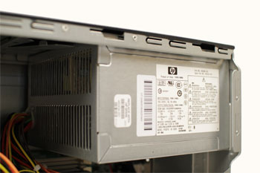

The power supply unit in a computer converts the power from the wall outlet to the type of power needed by the computer. It sends power through the cables to the motherboard and other components.

If you decide to open the computer case and take a look, make sure to unplug the computer first. Before touching the inside of the computer, you should touch a grounded metal object (or a metal part of the computer casing) to discharge any static buildup. Static electricity can be transmitted through the computer circuits and ruin them.

RAM (Random Access Memory)

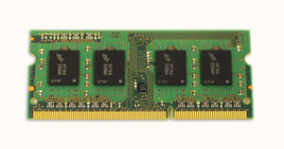

RAM is your system's short-term memory. Whenever your computer performs calculations, it temporarily stores the data in the RAM until it is needed.

This short-term memory disappears when the computer is turned off. If you're working on a document, spreadsheet, or other type of file, you'll need to save it to avoid losing it. When you save a file, the data is written to the hard drive, which acts as long-term storage.

RAM is measured in megabytes (MB) or gigabytes (GB). The more RAM you have, the more things your computer can do at the same time. If you don't have enough RAM, you may notice that your computer is sluggish when you have several programs open. Because of this, many people add extra RAM to their computers to improve performance.

A bit is the smallest unit of data in computer processing. A byte is a group of eight bits. A megabyte contains about one million bytes, and a gigabyte is about one billion bytes.

Hard Drive

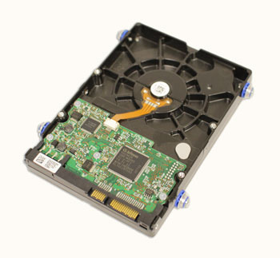

The hard drive is the data center of the computer. This is where the software is installed, and it's also where your documents and other files are stored. The hard drive is long-term storage, which means the data is still saved even if you turn the computer off or unplug it.

When you run a program or open a file, the computer copies some of the data from the hard drive onto the RAM so that it can access the data more easily. When you save a file, the data is copied back to the hard drive. The faster the hard drive is, the faster your computer can start up and load programs.

Most hard drives are hard disk drives, which store data on a magnetic platter. Some computers now use solid-state drives (also called flash hard drives). These are faster and more durable than hard disk drives, but they are also more expensive.

A USB flash drive is basically a small, removable flash hard drive that plugs into a USB port. These are a convenient way to bring your files with you and open them on a different computer.

If you're using Windows, you can view information about your computer's RAM and processor speed without opening up your computer. Just go to the Control Panel (in the Start menu) and click System and Security. In Mac OS X, you can view this information by clicking the Apple icon and selecting About This Mac.

Expansion Cards

Most computers have expansion slots on the motherboard that allow you to add various types of expansion cards. These are sometimes called PCI (Peripheral Component Interconnect) cards. You may never have to add any PCI cards, as most motherboards have built-in video, sound, network, and other capabilities. However, if you want to boost the performance of your computer or update the capabilities of an older computer, you can always add one or more cards. Below are some of the most common types of expansion cards:

Video card

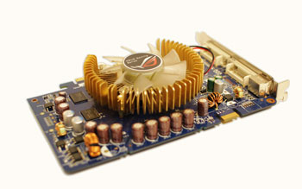

The video card is responsible for what you see on the monitor. Most computers have a GPU (Graphics Processing Unit) built into the motherboard, instead of having a separate video card. If you like playing graphics-intense games on the computer, you can add a faster video card to one of the expansion slots to get better performance.

Sound Card

The sound card, also called an audio card, is responsible for what you hear in the speakers or headphones. Most motherboards have integrated sound, but you can upgrade to a dedicated sound card for higher-quality sound.

Network Card

The network card allows your computer to communicate over a network and access the internet. It can either connect with an Ethernet cable or through a wireless connection (often called Wi-Fi). Many motherboards have built-in network connections, and a network card can also be added to an expansion slot.

Introduction

Take a look at the front and back of your computer case and count the number of buttons, sockets, and slots you see. Now, look at your monitor and count any that appear there. You probably counted at least 20.

Each computer is different, so the buttons, slots, and sockets will vary from computer to computer. However, there are certain features you can expect to find on most desktop computers. Being familiar with the names of each and how they are commonly used will help you later on when you connect that new printer, mouse, digital camera, or other device.

Front of Computer Case

Back of Computer Case

On the back of the computer case are connection ports that are made to fit specific devices. The arrangement of these varies from computer to computer, and many companies have their own special connectors for the specific devices. Some of the ports may be color coded to match a color on the device, which will help you determine which port is used with a particular device.

Peripherals You Can Use with Your Computer

The most basic computer setup usually includes the computer case, monitor, keyboard, and mouse, but you can plug many different types of devices into the extra ports on your computer. These devices are called peripherals. Below are a few examples of peripherals.

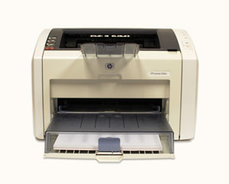

Printers: A printer is used to print documents, photos, or anything else that appears on your screen. There are many types of printers available, including inkjet, laser, and photo printers. You can also buy an all-in-one printer, scanner, and copier.

Scanners: A scanner allows you to copy an image or document and save it to your computer as a digital (computer-readable) image. Many scanners are included as part of an all-in-one printer/scanner/copier, although you can also buy a separate flatbed or handheld scanner.

Speakers/Headphones: Speakers and headphones are output devices, which means that they are devices that communicate information from the computer to the user. They allow you to hear sound and music. Depending on the model, they may connect to the audio port or the USB port. Some monitors also have built-in speakers.

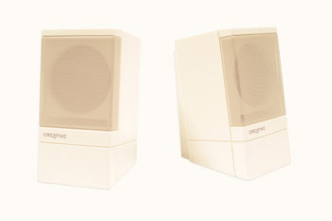

Microphones: A microphone is a type of input device, or a device that receives information from a user. You can connect the microphone to the computer and use the computer to record sound or to communicate with another computer user over the internet. Many computers come with built-in microphones.

Web Cameras: A web camera, or webcam, is a type of input device that can record videos or take pictures. It can also transmit video over the internet in real time, allowing you to do video chat or video conferencing with someone in a different part of the world. Webcams are used often in business, and they also help many friends and families stay connected.

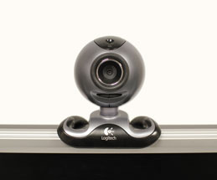

Joystick or Game Controller: A joystick is a lever that is used to control computer games. There are various other types of controllers that you can use, and you can also use your mouse and keyboard to control most games.

Digital Cameras: A digital camera lets you capture a picture or video in digital form. By connecting the camera to your computer's USB port, you can transfer the images from the camera to the computer. You can then print the images, email them to a friend, or post them on the Web.

Mobile Phones, MP3 Players, Tablet Computers, and Other Devices: When you buy an electronic device such as a mobile phone or mp3 player, check to see if it comes with a USB cable. If it does, that means you can connect it to your computer. With many devices, you can synchronize (or sync) them with your computer, which automatically keeps your contacts, music, and other data up-to-date whenever you connect the device to your computer.

http://www.gcflearnfree.org/